**Practical-3**

**Aim : Alice wants to send some confidential information to Bob over a secure network, you have to create perform following task :  
1)Provide Security using Caesar Cipher Algorithm  
2)Find the all possible Cipher Text & Plaintext pairs  
3)Provide Security Mono-alphabetic Cipher Algorithm**

**Caesar Cipher**

def encrypt(plain_text, key):

    cipher_text = ""

    for char in plain_text:

        if char.isalpha():

            ascii_offset = ord('a')

            encrypted_char = chr((ord(char.lower()) - ascii_offset + key) % 26 + ascii_offset)

            cipher_text += encrypted_char

        else:

            cipher_text += char

    return cipher_text

plain_text = input("Enter the plain text: ").lower()

key = int(input("Enter the key: "))

cipher_text = encrypt(plain_text, key)

print("Cipher text:", cipher_text)

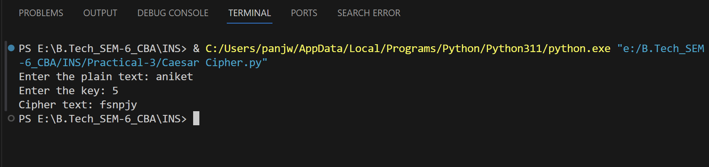

**Find the all possible Cipher Text & Plaintext pairs**

def decrypt(cipher_text, key):

    plaintext = ""

    for char in cipher_text:

        if char.isalpha():

            ascii_val = ord(char)

            decrypted_val = (ascii_val - key) % 26

            decrypted_char = chr(decrypted_val + ord('A'))

            plaintext += decrypted_char

        else:

            plaintext += char

    return plaintext

def find_all_plaintexts(cipher_text):

    all_plaintexts = []

    for key in range(26):

        plaintext = decrypt(cipher_text, key)

        all_plaintexts.append(plaintext)

    return all_plaintexts

cipher_text = input("Enter the cipher text: ")

plaintexts = find_all_plaintexts(cipher_text)

print("All possible plaintexts:")

for plaintext in plaintexts:

    print(plaintext)

**output :-**

**Provide Security Mono-alphabetic Cipher Algorithm**

def encrypt(plain_text, key):

    cipher_text = ""

    for char in plain_text:

        if char.isalpha():

            if char.isupper():

                index = ord(char) - ord('A')

                cipher_char = key[index].upper()

            else:

                index = ord(char) - ord('a')

                cipher_char = key[index].lower()

            cipher_text += cipher_char

        else:

            cipher_text += char

    return cipher_text

def decrypt(cipher_text, key):

    plain_text = ""

    for char in cipher_text:

        if char.isalpha():

            if char.isupper():

                index = ord(char) - ord('A')

                plain_char = chr(key[index].upper())

            else:

                index = ord(char) - ord('a')

                plain_char = chr(key[index].lower())

            plain_text += plain_char

        else:

            plain_text += char

    return plain_text

def main():

    key = []

    for i in range(26):

        key.append(input(f"Enter the key for '{chr(ord('a')+i)}': "))

    plain_text = input("Enter the plain text: ")

    cipher_text = encrypt(plain_text, key)

    print("Encrypted text:", cipher_text)

if __name__ == "__main__":

    main()

**output: -**

